**DEPLOYMENT OF APP IN IBM CLOUD**

**Upload Image To IBM Container Registry**

**TASK:** Push the Docker image for retail inventory management app to IBM Container Registry

• **LOGIN TO IBM CLOUD AND CREATE IBM CONTAINER REGISTRY** 

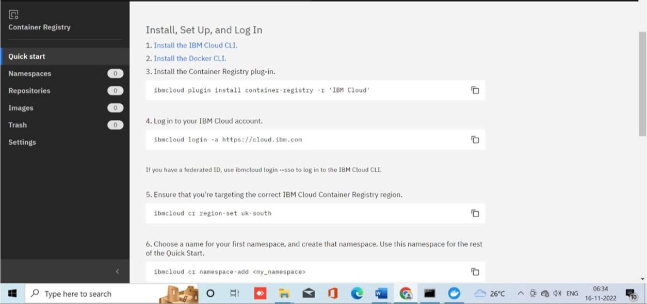

* **LOGIN TO IBM CLOUD CLI USING CMD** 

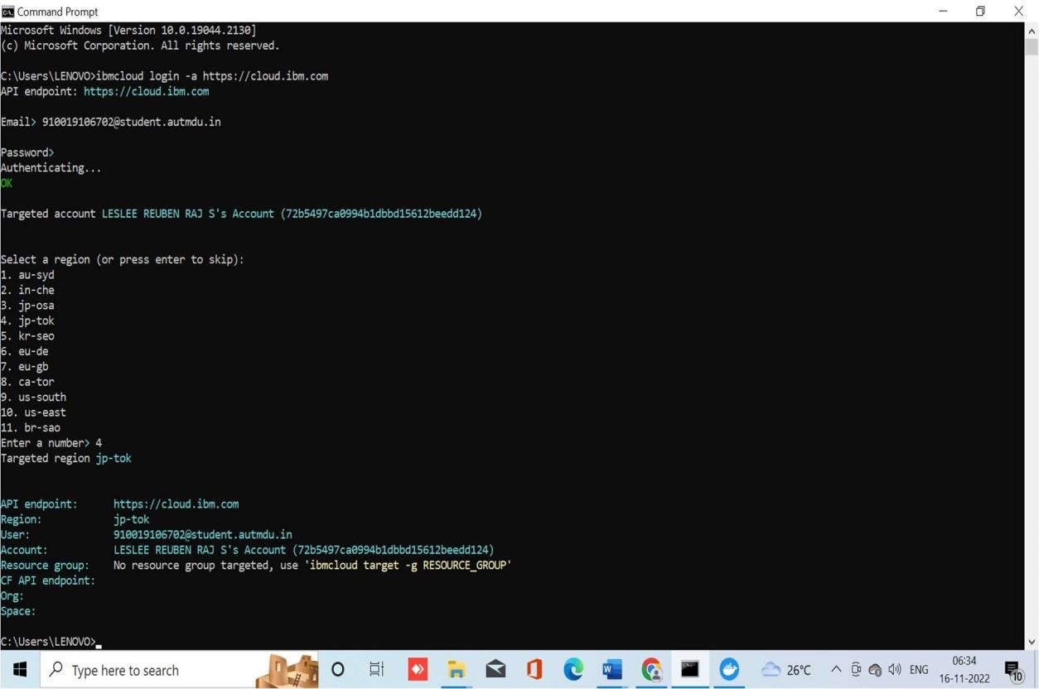

* **LOGIN TO DOCKER CLI AND PUSH THE IMAGE TO IBM CONTAINER REGISTRY** 

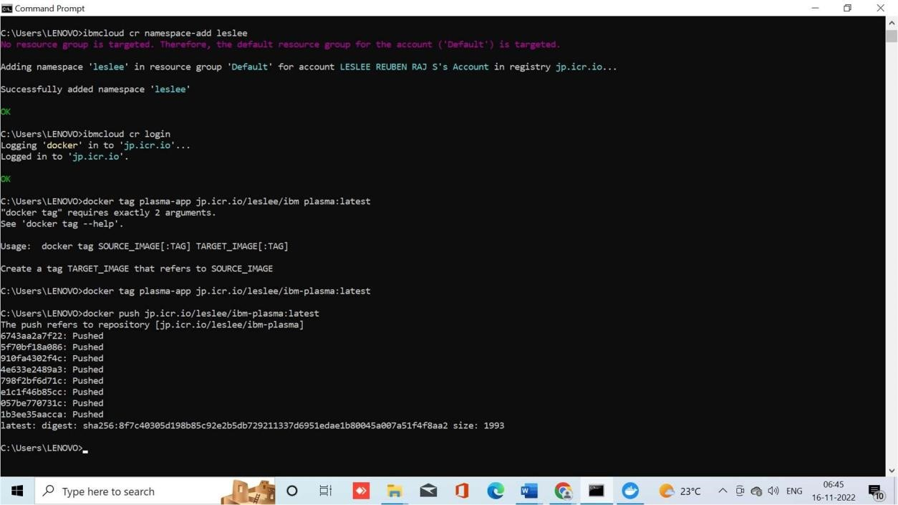

* **OUTPUT IN IBM CONTAINER REGISTRY** 

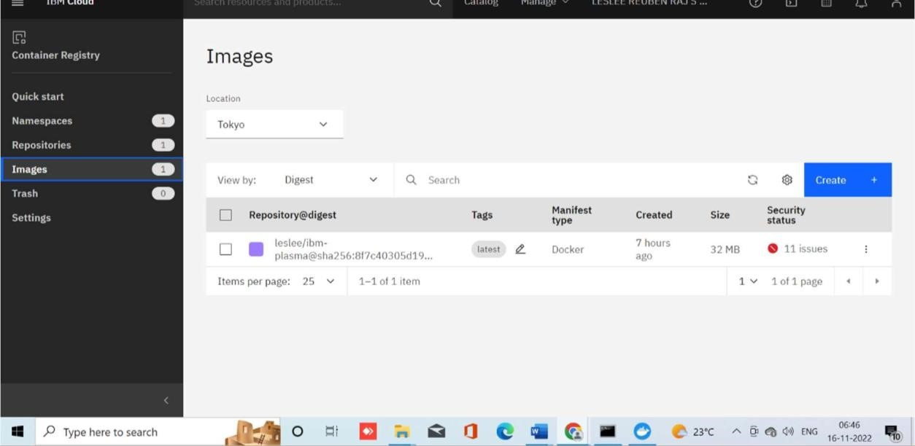

**TASK COMPLETED SUCCESSFULLY!**